- Rule 210(a)(2) is not clear about what “with the court’s permission” belongs to. Does it apply to pleading guilty and to pleading no contest? Or is just supposed to apply to no contest? Or does it apply to entering a plea by counsel in the absence of counsel or submitting a written plea?

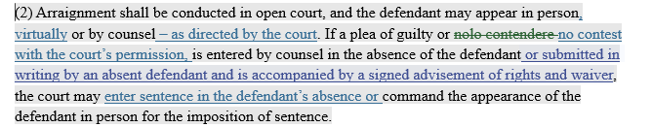

If it applies only to pleading no contest, I would separate it out. Something along the lines of:

If a plea of guilty or no contest with the court’s permission is entered by counsel in the absence of the defendant or submitted in writing by an absent defendant and is accompanied by a signed advisement of rights and waiver, the court may enter sentence in the defendant’s absence or command the appearance of the defendant in person for the imposition of sentence. The court must grant permission before a defendant may enter a plea of no contest.

- Also, seems like we need to change C.M.C.R. 211 and 232 too. If we are changing the phrase from “nolo contendere” to “no contest” we may want to change the language throughout the rules.

